Move3

/*

Adam Schachte

February 3,2012

ActionScript 2.0

You can move the camera freely when you hold the shift button.

When you move the character with the arrow keys, the camera follows him.

Left and right make him walk. Up and down make him rotate.

Ctrl makes him attack. The movement is still alitle choppy.

The drawing of a building just makes it easy to see the guy move.

*/

attack=false;

keyListener = new Object();

keyListener.onKeyDown = function() {

if (Key.isDown(Key.SHIFT)){//beginning of debug movement with shift button.

if (Key.isDown(Key.UP)&&Key.isDown(Key.DOWN)&&Key.isDown(Key.LEFT)&&Key.isDown(Key.RIGHT)){

trace("Up, Down, Left, and Right");//all 4 directions.

}

else if (Key.isDown(Key.UP)&&Key.isDown(Key.DOWN)&&Key.isDown(Key.LEFT)){

trace("Up, Down, and Left");//3 directions. Missing right.

}

else if (Key.isDown(Key.UP)&&Key.isDown(Key.DOWN)&&Key.isDown(Key.RIGHT)){

trace("Up, Down, and Right");//3 directions. Missing left.

}

else if (Key.isDown(Key.UP)&&Key.isDown(Key.LEFT)&&Key.isDown(Key.RIGHT)){

trace("Up, Left, and Right");//3 directions. Missing down.

_y=_y+10;//moves stage up

}

else if (Key.isDown(Key.DOWN)&&Key.isDown(Key.LEFT)&&Key.isDown(Key.RIGHT)){

trace("Down, Left, and Right");//3 directions. Missing up.

_y=_y-10;

}

else {//Beginning of the 2 directional code.

if (Key.isDown(Key.UP)&&Key.isDown(Key.DOWN)){

trace("Up and Down");//2 directions. 1st up. 1st down.

}

else if (Key.isDown(Key.UP)&&Key.isDown(Key.LEFT)){

trace("Up and Left");//2 directions. 2nd up. 1st left.

_y=_y+10;//moves stage up

_x=_x+10;//moves stage left

}

else if (Key.isDown(Key.UP)&&Key.isDown(Key.RIGHT)){

trace("Up and Right");//2 directions. 3rd up. 1st right.

_y=_y+10;//moves stage up

_x=_x-10;//moves stage right

}

else if (Key.isDown(Key.DOWN)&&Key.isDown(Key.LEFT)){

trace("Down and Left");//2 directions. 2nd down. 2nd left.

_y=_y-10;//moves stage down

_x=_x+10;//moves stage left

}

else if (Key.isDown(Key.DOWN)&&Key.isDown(Key.RIGHT)){

trace("Down and Right");//2 directions. 3rd down. 2nd right.

_y=_y-10;//moves stage down

_x=_x-10;//moves stage right

}

else if (Key.isDown(Key.LEFT)&&Key.isDown(Key.RIGHT)){

trace("Left and Right");//2 directions. 3rd left. 3rd right.

}

else {//Beginning of the 1 direction.

if (Key.isDown(Key.UP)){

trace("Up");

//blue1.y=blue1.y+10;

_y=_y+10;//moves stage up

}

else if (Key.isDown(Key.DOWN)){

trace("Down");

_y=_y-10;//moves stage down

}

else if (Key.isDown(Key.LEFT)){

trace("Left");

_x=_x+10;//moves stage left

}

else if (Key.isDown(Key.RIGHT)){

trace("Right");

_x=_x-10;//moves stage right

}

}//end of the 1 directional code.

}//end of the else statement that started the 2 directional code.

}//end of debug movement.

else {

if ((Key.isDown(Key.LEFT)or keyPress=="a")and

(Key.isDown(Key.RIGHT)or keyPress=="d")){

trace("character left and right");

if (!attack) {

blue1.gotoAndStop("stance");

}

}//end of if left and right are pressed statement.

else {

if ((Key.isDown(Key.LEFT)or keyPress=="a")and

(!Key.isDown(Key.RIGHT)and keyPress!="d")){

blue1._rotation=0;

blue1._xscale=-100;

blue1._x-=5;

trace("character left");

if (!attack) {

blue1.gotoAndStop("walk");

}

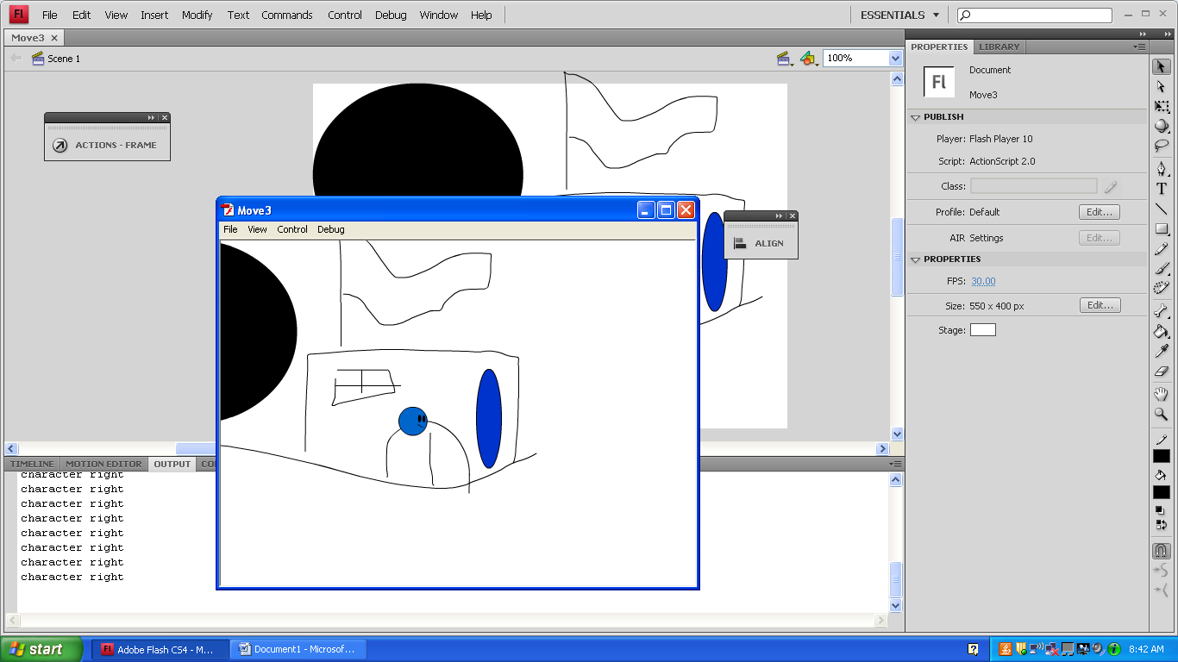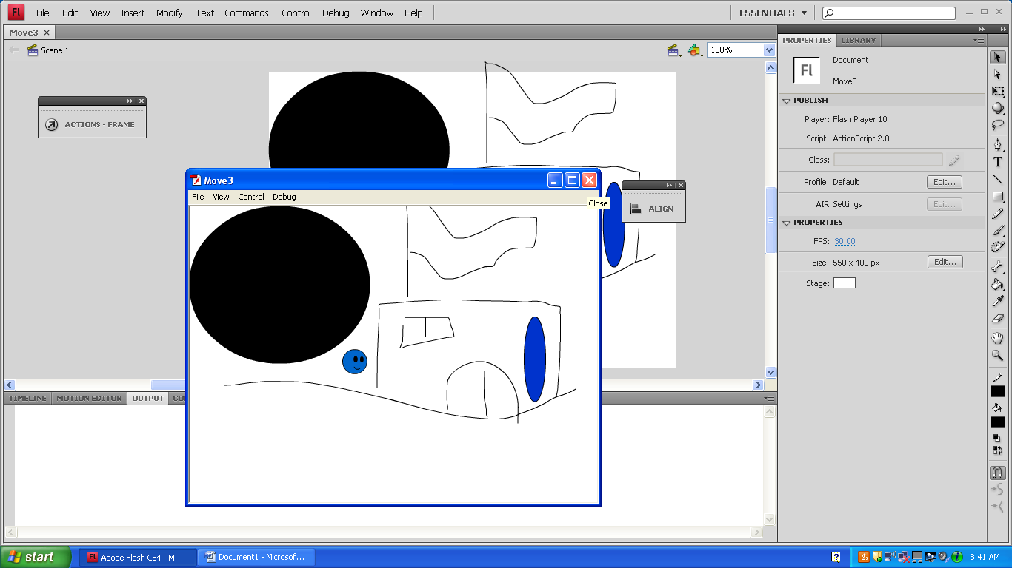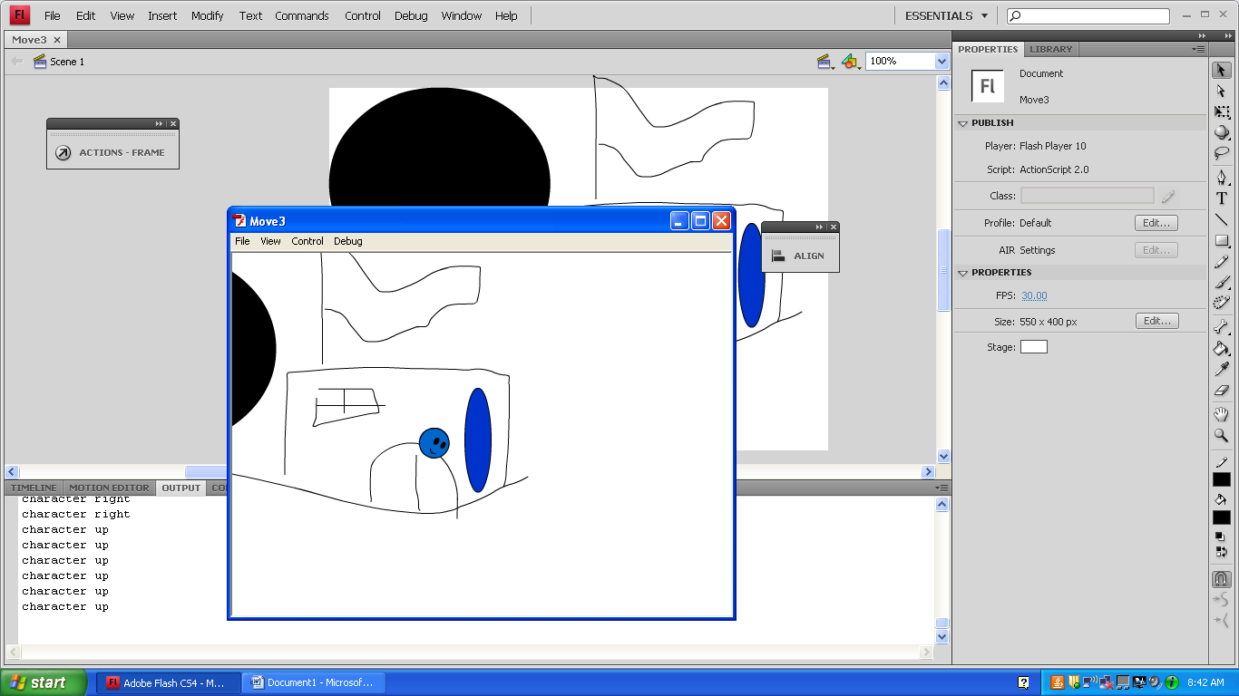 }//end of if left is pressed statement.

if ((!Key.isDown(Key.LEFT)or keyPress!="a")and

(Key.isDown(Key.RIGHT)or keyPress=="d")){

blue1._rotation=0;

blue1._xscale=100;

blue1._x+=5;

trace("character right");

if (attack==false) {

blue1.gotoAndStop("walk");

}

}//end of if right is pressed statement.

}//end of else statement.

//Left/right movement should be indepentent of up/down movement.

if ((Key.isDown(Key.DOWN)or keyPress=="s")&&

(Key.isDown(Key.UP)or keyPress=="w")){

trace("character up and down");

}

else if (Key.isDown(Key.DOWN)or keyPress=="s"){

trace ("character down");

blue1._rotation-=5;

}

else if (Key.isDown(Key.UP)or keyPress=="w"){

trace ("character up");

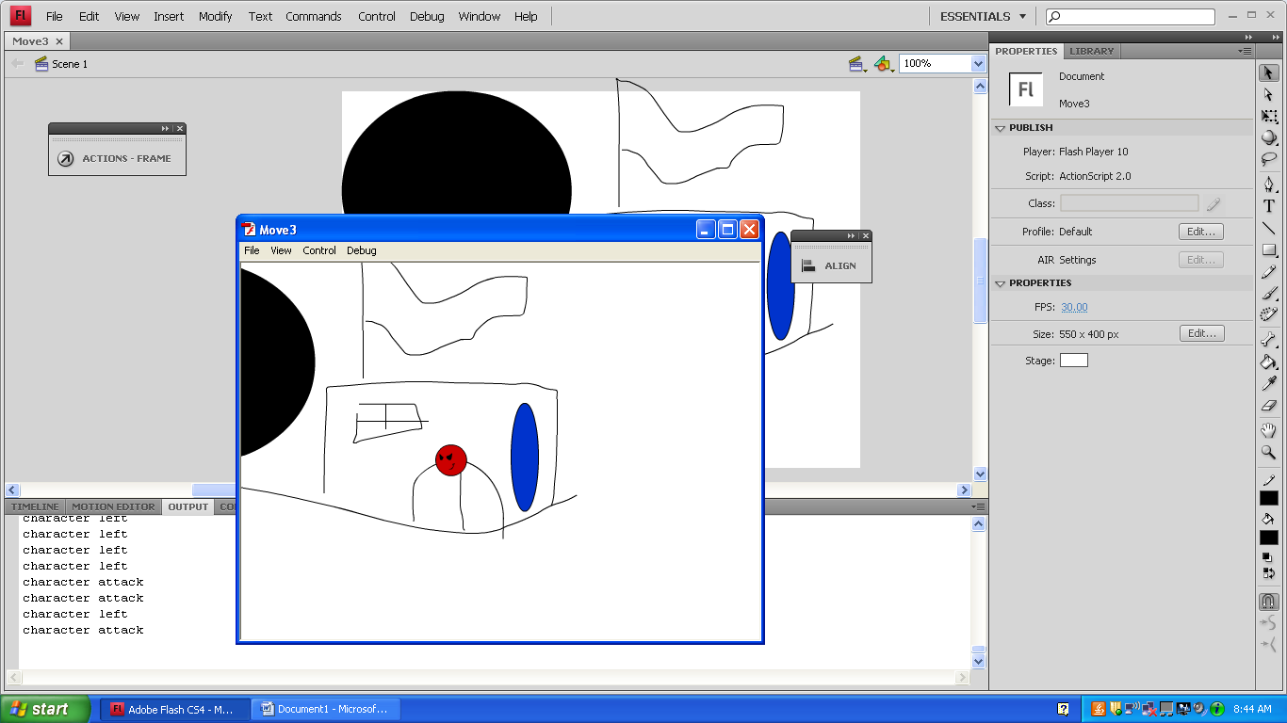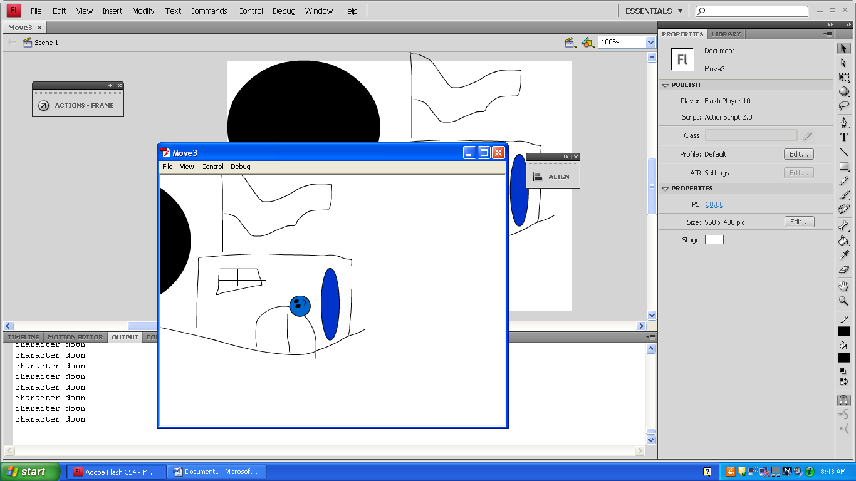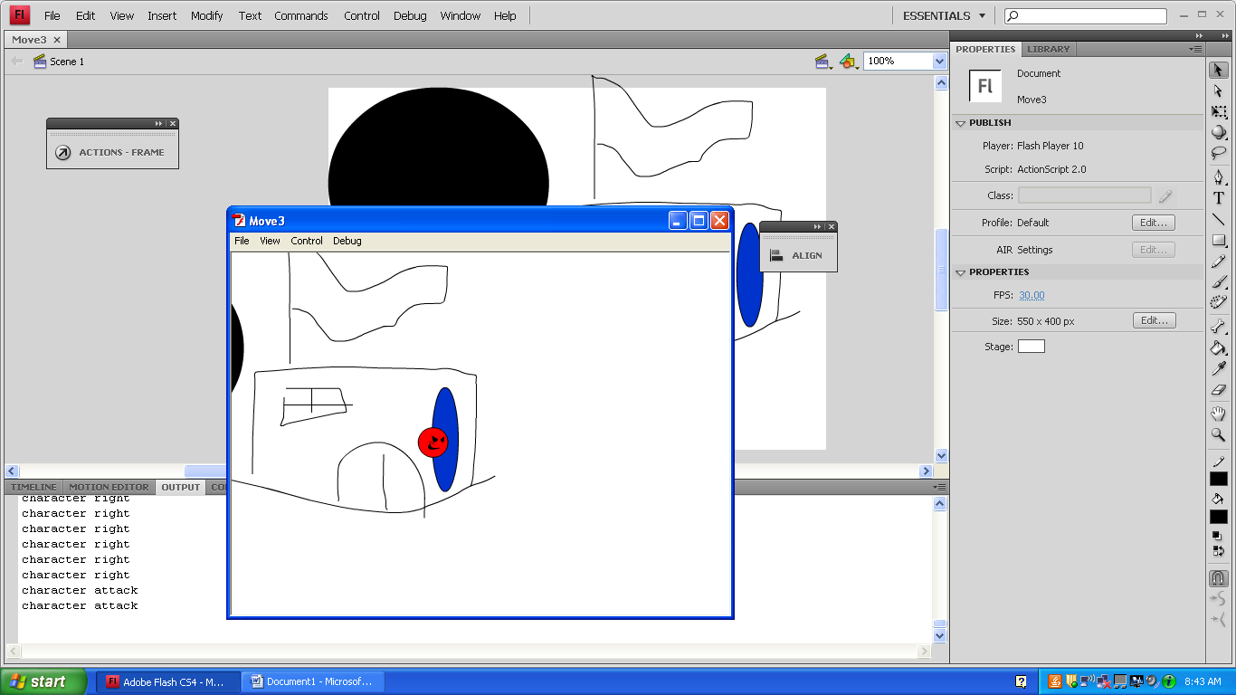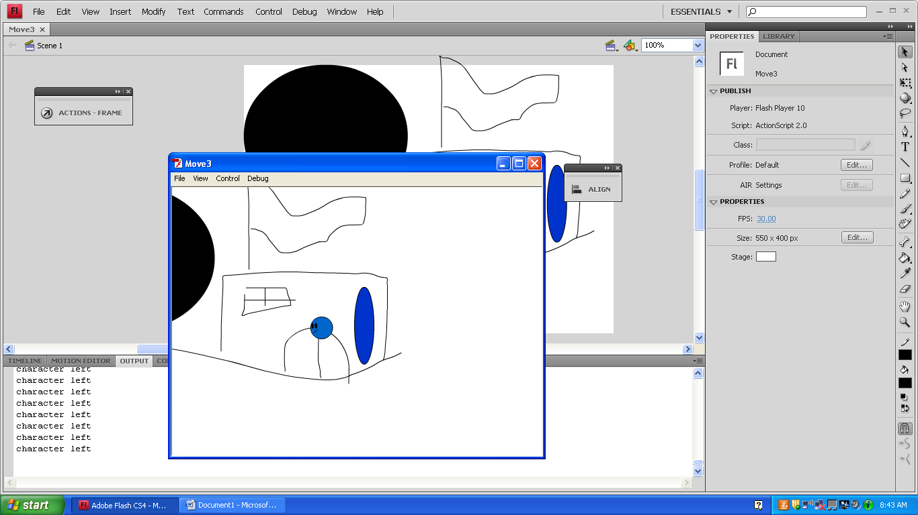 blue1._rotation+=5;

}

else if (Key.isDown(Key.CONTROL)){

attack=true;

blue1.gotoAndStop("attack");

trace("character attack");

}

if (attack){

blue1.gotoAndStop("attack");

trace("character attack");

}

}//end of character movement.

//camera movement.

if (!Key.isDown(Key.SHIFT)){

_root._x=-(blue1._x)+222.85

_root._y=-(blue1._y)+209.75

}

}//end of keyListener.onKeyDown = function()

Key.addListener(keyListener);